

**DATABASE**

**SPECIFICATIONS**

*Ayobami Adebowale, Marilyn Flowers, Won Geun Oh, Maksym Melnyk*

**ITMD 321: Data Modeling and Applications**

**Professor Maurice Dawson**

December 2020

**Revision Sheet**

|  |  |  |
| --- | --- | --- |
| **Release No.** | **Date** | **Revision Description** |
| Rev. 0 | 12/09/20 | Initialization of Database Specification Document |
|  |  |  |
|  |  |  |
|  |  |  |
|  |  |  |
|  |  |  |
|  |  |  |

|  |  |
| --- | --- |
|  | **Database Specifications Authorization Memorandum** |

I have carefully assessed the Database Specifications for the Global Terrorism Database (GTD). This document has been completed in accordance with the requirements of the HUD System Development Methodology.

MANAGEMENT CERTIFICATION - Please check the appropriate statement.

___X___ The document is accepted.

______ The document is accepted pending the changes noted.

______ The document is not accepted.

We fully accept the changes as needed improvements and authorize initiation of work to proceed. Based on our authority and judgment, the continued operation of this system is authorized.

Maksym Melnyk 12/04/2020__________

NAME DATE

Group Member

Ayobami Adebowale ___12/09/20__________

NAME DATE

Group Member

Marilyn Flowers 12/10/2020___________

NAME DATE

Group Member

Won Geun Oh 12/10/2020___________

NAME DATE

Group Member

**DATABASE SPECIFICATIONS**

**TABLE OF CONTENTS**

Page #

***1.0*** ***GENERAL INFORMATION*** [***1-1***](https://docs.google.com/document/d/1K8LGMKK0WJKMHojiJDDcQhnvpnJlqoi-nSGvxX1pX2g/edit#heading=h.2dlolyb)

**1.1** **Purpose** [**1-1**](https://docs.google.com/document/d/1K8LGMKK0WJKMHojiJDDcQhnvpnJlqoi-nSGvxX1pX2g/edit#heading=h.sqyw64)

**1.2** **Scope** [**1-1**](https://docs.google.com/document/d/1K8LGMKK0WJKMHojiJDDcQhnvpnJlqoi-nSGvxX1pX2g/edit#heading=h.3cqmetx)

**1.3** **System Overview** [**1-1**](https://docs.google.com/document/d/1K8LGMKK0WJKMHojiJDDcQhnvpnJlqoi-nSGvxX1pX2g/edit#heading=h.1rvwp1q)

**1.4** **Project References** [**1-1**](https://docs.google.com/document/d/1K8LGMKK0WJKMHojiJDDcQhnvpnJlqoi-nSGvxX1pX2g/edit#heading=h.4bvk7pj)

**1.5** **Acronyms and Abbreviations** [**1-2**](https://docs.google.com/document/d/1K8LGMKK0WJKMHojiJDDcQhnvpnJlqoi-nSGvxX1pX2g/edit#heading=h.2r0uhxc)

**1.6** **Points of Contact** [**1-2**](https://docs.google.com/document/d/1K8LGMKK0WJKMHojiJDDcQhnvpnJlqoi-nSGvxX1pX2g/edit#heading=h.1664s55)

1.6.1 Information [1-2](https://docs.google.com/document/d/1K8LGMKK0WJKMHojiJDDcQhnvpnJlqoi-nSGvxX1pX2g/edit#heading=h.3q5sasy)

1.6.2 Coordination [1-2](https://docs.google.com/document/d/1K8LGMKK0WJKMHojiJDDcQhnvpnJlqoi-nSGvxX1pX2g/edit#heading=h.25b2l0r)

1.6.3 Additional Points of Contact [1-2](https://docs.google.com/document/d/1K8LGMKK0WJKMHojiJDDcQhnvpnJlqoi-nSGvxX1pX2g/edit#heading=h.kgcv8k)

1.6.4 Data Owners [1-2](https://docs.google.com/document/d/1K8LGMKK0WJKMHojiJDDcQhnvpnJlqoi-nSGvxX1pX2g/edit#heading=h.34g0dwd)

***2.0*** ***DATABASE IDENTIFICATION AND DESCRIPTION 2-1***

**2.1** **Naming Conventions** [**2-1**](https://docs.google.com/document/d/1K8LGMKK0WJKMHojiJDDcQhnvpnJlqoi-nSGvxX1pX2g/edit#heading=h.1jlao46)

**2.2** **Database Identification** [**2-1**](https://docs.google.com/document/d/1K8LGMKK0WJKMHojiJDDcQhnvpnJlqoi-nSGvxX1pX2g/edit#heading=h.43ky6rz)

**2.3** **Systems Using the Database** [**2-1**](https://docs.google.com/document/d/1K8LGMKK0WJKMHojiJDDcQhnvpnJlqoi-nSGvxX1pX2g/edit#heading=h.2iq8gzs)

**2.4** **Relationship to Other Databases** [**2-1**](https://docs.google.com/document/d/1K8LGMKK0WJKMHojiJDDcQhnvpnJlqoi-nSGvxX1pX2g/edit#heading=h.xvir7l)

**2.5** **Schema Information** [**2-1**](https://docs.google.com/document/d/1K8LGMKK0WJKMHojiJDDcQhnvpnJlqoi-nSGvxX1pX2g/edit#heading=h.3hv69ve)

2.5.1 Description [2-1](https://docs.google.com/document/d/1K8LGMKK0WJKMHojiJDDcQhnvpnJlqoi-nSGvxX1pX2g/edit#heading=h.1x0gk37)

2.5.2 Physical Design [2-1](https://docs.google.com/document/d/1K8LGMKK0WJKMHojiJDDcQhnvpnJlqoi-nSGvxX1pX2g/edit#heading=h.4h042r0)

2.5.3 Physical Structure [2-1](https://docs.google.com/document/d/1K8LGMKK0WJKMHojiJDDcQhnvpnJlqoi-nSGvxX1pX2g/edit#heading=h.2w5ecyt)

**2.6** **Data Dictionary** [**2-1**](https://docs.google.com/document/d/1K8LGMKK0WJKMHojiJDDcQhnvpnJlqoi-nSGvxX1pX2g/edit#heading=h.1baon6m)

**2.7** **Special Instructions** [**2-2**](https://docs.google.com/document/d/1K8LGMKK0WJKMHojiJDDcQhnvpnJlqoi-nSGvxX1pX2g/edit#heading=h.3vac5uf)

***3.0*** ***DATABASE ADMINISTRATIVE INFORMATION*** [***2-1***](https://docs.google.com/document/d/1K8LGMKK0WJKMHojiJDDcQhnvpnJlqoi-nSGvxX1pX2g/edit#heading=h.2afmg28)

**3.1** **Responsibility 2-1**

3.2.1 Database Management System (DBMS) Configuration 2-2

3.2.2 Hardware Configuration 2-2

3.2.3 Database Software Utilities [2-2](https://docs.google.com/document/d/1K8LGMKK0WJKMHojiJDDcQhnvpnJlqoi-nSGvxX1pX2g/edit#heading=h.pkwqa1)

3.2.4 Support Software Available for Maintaining Database 2-3

**3.3** **Storage Requirements 2-4**

**3.4** **Recovery 2-5**

**3.5** **Partition/File Information 2-5**

3.5.1 Content 2-5

3.5.2 Description 2-6

3.5.3 Partition/File Interdependencies

**1.0 GENERAL INFORMATION**

1. **GENERAL INFORMATION**

**1.1 Purpose**

The main purpose of this Database Specification document is to provide information on the configuration, architecture, controls and testing of our databases. This information is available for utilization by stakeholders including but not limited to the client, database administrator, and developers. It is to serve functionally for database support and testing purposes.

**1.2 Scope**

The scope of the database specifications is limited to the following:

* Database Identification and Description
* Database Design and Architecture
* Database Administrative Information
* Summary of Security Controls

**1.3 System Overview**

Our database is one of the thousands of available databases containing information on the general concepts of crime. We have chosen this database to effectively exhibit security control and detailed database documentation. This database specifically analyzes the certain aspects of crime such as gun type, murder charge, and motive. More detailed information concerning the database can be found below:

|  |  |
| --- | --- |
| Document Owner | Ayobami Adebowale, Marilyn Flowers, Won Geun Oh, Maksym Melnyk |
| System Name | Final_Project_ITMD |
| Source Code | <https://github.com/kpuiiuiii/ITMD-321-FinalProject> |
| System Environment | Variable OS running MySQL |
| Document Status |  |
|  |  |

Title : Couch Company

* Target : entrepreneurs, small business owners
* Contents : build a marketplace to connect businessman and service provider (landlord, real estate broker, financial/ taxation consultant, business consultant, utility(Gas, Telecom, Appliance, Security/ Sanitation service bundle service) bundle and POS
* Key works :
* Building mobile marketplace where landlord upload their property
* Payment solution for the rent and trade
* Gathering service provider (Finance, Business Consultants, Interior)
* Packaging Service bundle for utility
* Needs to prepare for service extension (Prefab house, and bus operator)

**1.4 Project References**

Below is a list of the references that were used in preparation of this document*:*

* Previously developed documents relating to the project
* Database
* HUD DOC_15145.DOC Database Specifications Template

**1.5 Acronyms and Abbreviations**

Provide a list of the acronyms and abbreviations used in this document and the meaning of each.

* SQL (i.e. SQL, MySQL) - Structured Query Language
* HUD- [sic] U.S. Department of Housing and Urban Development
* GTD- Global Terrorism Database
* EER- Enhanced Entity Relationship Diagram

**1.6 Points of Contact**

**1.6.1 Information**

Below is a list of the points of organizational contact (POCs) that may be needed by the document user for informational and troubleshooting purposes:

Include type of contact, contact name, department, telephone number, and e-mail address (if applicable).  Points of contact may include, but are not limited to, helpdesk POC, development/maintenance POC, and operations POC.

**1.6.2 Coordination**

Below is a list of organizations that require coordination between the project:

and its specific support function (e.g., installation coordination, security, etc.).  Include a schedule for coordination activities.

**1.6.3 Additional Points of Contact**

Additional points of contact are included in section 3.1.

**1.6.4 Data Owners**

The database has been retrieved directly from hud points of contact for those who either own or are responsible for data quality, currency, accuracy, etc.

* 1. **DATABASE IDENTIFICATION AND DESCRIPTION**

# 2.0 DATABASE IDENTIFICATION AND DESCRIPTION

## 2.1 Naming Conventions

The naming standards were simply according to the type of data provided as well as the name of the project itself.

## 2.2 Database Identification

Our database is one of the many databases containing information on the general concept of crime. As seen in earlier slides, this database specifically analyzes the certain aspects of crime such as gun type, murder charge, and motive. Below, the names or labels by which the database may be uniquely identified are listed. The code name, tag, or label by which each database table or file may be uniquely identified is specified as follows:

.

Database Title:

* Final_Project_ITMD

Tables (20 items):

* AdditionalInfo
* AttackType
* Book1
* Claimed
* GroupName
* Gun
* HostageInfo
* Hostages
* Killed
* Location
* MediaCoverage
* Motive
* Outcome
* Property
* Ransom
* Summary
* TargetType
* Time
* weaponType
* Wounded

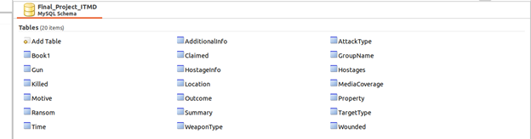

Figure 2.2

Figure 2.2 above is a screen capture of the database labels in the working environment (MySQL).

## 2.3 Systems Using the Database

No separate system will be utilizing the database outside the chosen work environment (i.e MySQL)

## 2.4 Relationship to Other Databases

Final_Project_ITMD will not be interacting with any other databases.

## 2.5 Schema Information

The Final_Project_ITMD schema consists only of the actual database and 20 tables containing the data specifically on types of crime.

### 2.5.1 Description

Our system was initialized using the CREATE, DROP and ALTER commands Lastly, the database Final_Project_ITMD is a simple database without any sub-schemas.

### 2.5.2 Physical Design

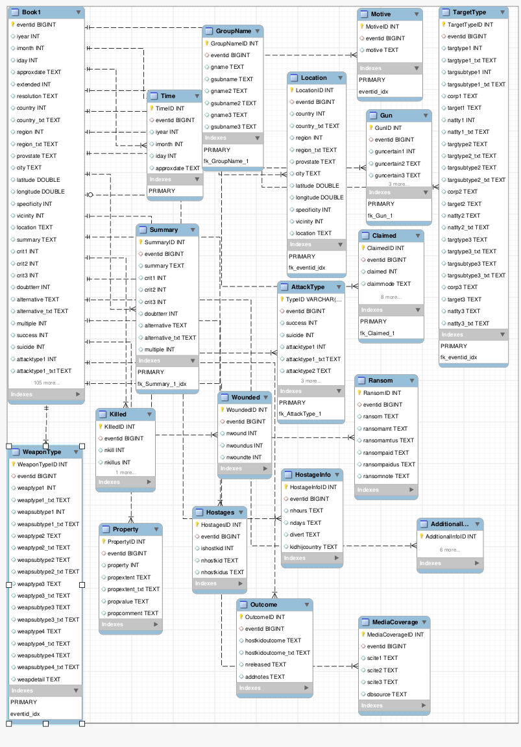

Figure 2.5.2

Figure 2.5.4 is an EER diagram that depicts the physical design of the database Final_Project_ITMD

### 2.5.3 Physical Structure

Describe and depict in a graphic representation the physical structure (partitions, files, indexes, pointers) and the logical components of the database.  Identify the criteria required to achieve operating efficiency.

## 2.6 Data Dictionary

|  |  |  |  |
| --- | --- | --- | --- |
|  | Name | Type | Description |
| 1 | AdditionalInfo |  | Additional information about the event |
| 2 | AttackType |  | All if the information regarding the type of attack and success rate |
| 3 | Book1 | Includes all columns of the database | - |
| 4 | Claimed |  | All of the information regarding the claimed |
| 5 | GroupName |  | All of the information about the Group Name |
| 6 | Gun |  | All of the information about the Gun used |
| 7 | HostageInfo |  | All of the information about the Hostages |
| 8 | Hostages |  | All of the information about the children hostages |
| 9 | Killed |  | All of the information about the killed people |
| 10 | Location |  | All of the information about the location |
| 11 | MediaCoverage |  | All of the information about the coverage by the Media |
| 12 | Motive |  | Group motive |
| 13 | Outcome |  | All of the information about the result of the act |
| 14 | Property |  | All of the information about the property damage |
| 15 | Ransom |  | All of the information about the ransom |
| 16 | Summary |  | All of the information about the overall summary |
| 17 | TargetType |  | All of the information about the type of the target |
| 18 | Time |  | All of the information about the time and date |
| 19 | WeaponType |  | All of the information about the weapon used |
| 20 | Wounded |  | All of the information about the wounded |

## 2.7 Special Instructions

For instructions to be followed by personnel who will contribute to the generation of the database and who will use it for testing and operational purposes, please refer to the Group Presentation and Project Document uploaded by Dr. Maurice Dawson. A summary of such instructions can be found below: include:

* Design a database that captures crimes or nefarious acts
* Identify source documents for the rules and procedures to be followed when submitting data for entry into the database.
* Identify source documents for the machine run instructions for generating, modifying, updating, or otherwise using the database.  In very large systems, in which the details of such instructions are extensive, reference sections of other documents in which this specific information may be found.

**3.0 DATABASE ADMINISTRATIVE INFORMATION**

# 3.0 DATABASE ADMINISTRATIVE INFORMATION

## 3.1 Responsibility

**Database administrator:**

* Install and maintain the performance of database servers.
* Develop processes for optimizing database security.
* Set and maintain database standards.
* Manage database access.
* Performance tuning of database systems.
* Install, upgrade, and manage database applications.
* Diagnose and troubleshoot database errors.
* Recommend and implement emerging database technologies.
* Create and manage database reports, visualizations, and dashboards.
* Create automation for repeating database tasks.
* Be available for on-call support as needed.

**System administrator:**

* Install and configure software and hardware.
* Manage network servers and technology tools.
* Set up accounts and workstations.
* Monitor performance and maintain systems according to requirements.
* Troubleshoot issues and outages.
* Ensure security through access controls, backups and firewalls.
* Upgrade systems with new releases and models.
* Develop expertise to train staff on new technologies.
* Build an internal wiki with technical documentation, manuals and IT policies.

**Security administrator:**

* Create, drop, alter, and rename security label components
* Create, drop, and rename security policies
* Create, drop, and rename security labels
* Attach security policies to tables and detach security policies
* Grant security labels to users and revoke security labels
* Grant and revoke exemptions from security policies

**3.2 System Information**

### 3.2.1 Database Management System (DBMS) Configuration

A Database Management System is defined as the software system that allows users to define, create, maintain and control access to the database. A DBMS helps to define, create, manipulate and share the database among different users and applications.



### 3.2.2 Hardware Configuration

Please find the hardware configurations on which the database will reside.

|  |  |
| --- | --- |
| **Configuration Item** | **Data event management and impact event management** |
| Platform | * Intel Core i7 CPU: 4 vCPU, Frequency: 2.2 GHz and Threads :16 * SPARC Enterprise T-Series or M-Series Servers,  CPU: 4 CPUs, of 3 GHz, UltraSPARC T2, and 32 threads or more * CPU: 4 vCPU, Frequency: 2.2GHz and threads :16 |
| RAM | 8 GB |
| Storage configuration | 200 GB (30 GB for the server + 170 GB for the database)  15000 RPM drive or a tier 1 SAN storage (2-4 GBps SAN dedicated channel) |

### 3.2.3 Database Software Utilities

* + 1. DBMS software can include System profilers, Network Managers, Application Launchers, disk repair, file manager, file compression and data security. These all apply to the database as data was transferred into the database and managed to properly handle the opening of all test tables. These software utilities help to open the program, MySQL, and allows for the programming of data. Although the efforts seem to be minimal, there are surfaces of development that are ignored. A consumer normally does not think about the efforts made and establish the level of necessity for all operations to run under simple utilities mentioned above. These all work together to keep the created database up to date and the software allows real time translation and projection.

### 3.2.4 Support Software Available for Maintaining Database

Support software such as MySQL and Workbench and many more are considered normal support software but for this project specifically, MySQL and Workbench. were considered essential as they were directly related to the database.

|  |  |  |  |
| --- | --- | --- | --- |
| Name | Version | Function | Major operating characteristics |
| Ubuntu | 20.04.1 LTS (x86_64) | Operation system | * Open Source * Multi-User * Multi Programmable * Portable |
| MySQL | 20.10 (x86, 64-bit) | Database management system | * Data Security * On-Demand Scalability * High Performance * Comprehensive Transactional Support * Complete Workflow Control * Reduced Total Cost of Ownership * The Flexibility of Open Source |
| MySQL Workbench | 20.10 (x86, 64-bit) | * Visual database design tool * Report Writer * Query language * Database loading software * Storage allocation * File processing program * Data cleaning software | * Design * Develop * Administer |

## 3.3 Storage Requirements

All the information in a database is organized and structured in database tables. These tables are stored on the hard disk of the database server. The database tables are divided into columns and rows, just like a regular graphic table. In a database table, the columns specify the information category and the data type, and the rows hold the actual information. This structure is chosen for its ease of use – it can be easily indexed, accessed or modified.

|  |  |
| --- | --- |
| Database component | **Size** |
| Field storage | = 272*255  = 69360 |
| Book1 table | = number of records * field storage * 1.5  = 92,313,664 * 69,360 * 1.5  = 9,604,313,602,560 |
| Name index | = number of records x (7 + number of fields in index + index field storage) * 2  = 92,313,664 * (7 + 2 + 272) * 2  = 103,760,558,336 |

## 3.4 Recovery

It is important to back up your databases so that you can recover your data and be up and running again in case problems occur, such as system crashes, hardware failures, or users deleting data by mistake. Backups are also essential as a safeguard before upgrading a MySQL installation, and they can be used to transfer a MySQL installation to another system or to set up replica servers. *Mysqldump* is a command-line utility that is used to generate the logical backup of the MySQL database. It produces the SQL Statements that can be used to recreate the database objects and data.

## 3.5 Partition/File Information

### 3.5.1 Content

Partitioning is the database process where very large tables are divided into multiple smaller parts. By splitting a large table into smaller, individual tables, queries that access only a fraction of the data can run faster because there is less data to scan. The main goal of partitioning is to aid in maintenance of large tables and to reduce the overall response time to read and load data for particular SQL operations.

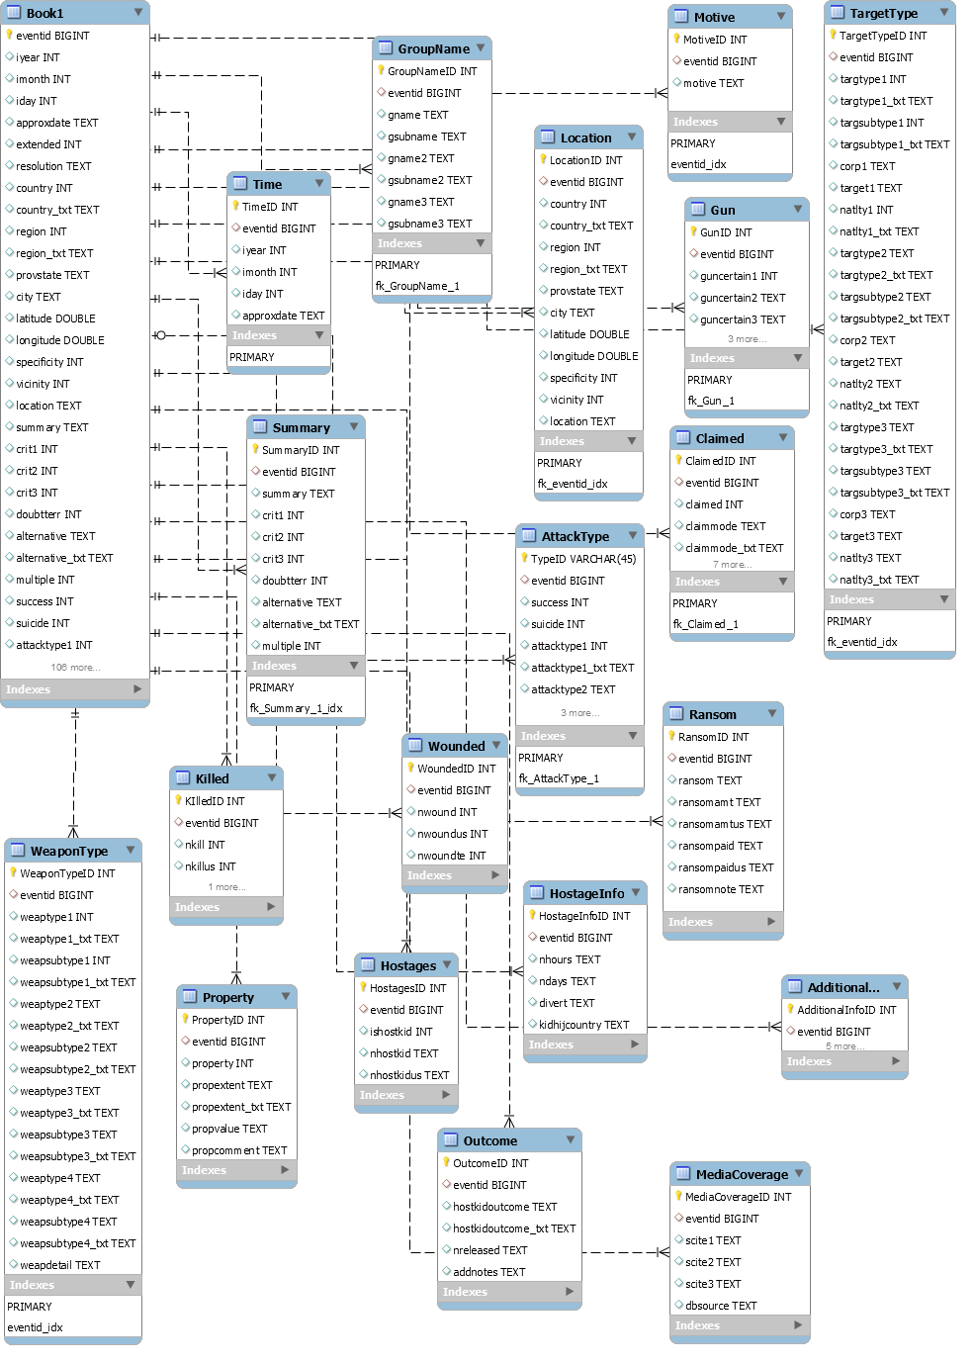

Database partition EER Diagram

### 3.5.2 Description

|  |  |  |
| --- | --- | --- |
| Name | Type | Description |
| AdditionalInfo |  | Additional information about the event |
| AttackType |  | All if the information regarding the type of attack and success rate |
| Book1 | Includes all columns of the database | - |
| Claimed |  | All of the information regarding the claimed |
| GroupName |  | All of the information about the Group Name |
| Gun |  | All of the information about the Gun used |
| HostageInfo |  | All of the information about the Hostages |
| Hostages |  | All of the information about the children hostages |
| Killed |  | All of the information about the killed people |
| Location |  | All of the information about the location |
| MediaCoverage |  | All of the information about the coverage by the Media |
| Motive |  | Group motive |
| Outcome |  | All of the information about the result of the act |
| Property |  | All of the information about the property damage |
| Ransom |  | All of the information about the ransom |
| Summary |  | All of the information about the overall summary |
| TargetType |  | All of the information about the type of the target |
| Time |  | All of the information about the time and date |
| WeaponType |  | All of the information about the weapon used |
| Wounded |  | All of the information about the wounded |